|  |  |
| --- | --- |
|  | AIR UNIVERSITY |
| DEPARTMENT OF COMPUTING AND AI |
| EXPERIMENT NO 7 |

LAB TITLE: LAB REPORT 7

STUDENT NAME: Ruhma Lodhi REG NO: 230452

LAB ASSESSMENT:

|  |  |  |  |  |  |
| --- | --- | --- | --- | --- | --- |
| Attributes | Excellent  (5) | Good  (4) | Average  (3) | Satisfactory  (2) | Unsatisfactory  (1) |
| Ability to Conduct Experiment |  |  |  |  |  |
| Ability to assimilate the results |  |  |  |  |  |
| Effective use of lab equipment and follows the lab safety rules |  |  |  |  |  |

Total Marks:  Obtained Marks: 

LAB REPORT ASSESSMENT:

|  |  |  |  |  |  |
| --- | --- | --- | --- | --- | --- |
| Attributes | Excellent  (5) | Good  (4) | Average  (3) | Satisfactory  (2) | Unsatisfactory  (1) |
| Data presentation |  |  |  |  |  |
| Experimental results |  |  |  |  |  |
| Conclusion |  |  |  |  |  |

Total Marks:  Obtained Marks: 

Date:  Signature: 

# Experiment 7

Seven Segment display

OBJECTIVES:

* To experimentally check the operation of 7-segment display using BCD to 7-segment decoder 4774.

Requires component and Equipment’s:

* ICs as required.
* Digital Electronic trainer.

Procedure:

* Check the configuration of your 7-segment display using multi-meter. Find out its configuration and pin-assignment.
* Create the truth table to describing the function of a BCD to 7-segment decoder accordingly to the configuration of your display.

|  |  |  |  |  |  |  |  |  |  |  |
| --- | --- | --- | --- | --- | --- | --- | --- | --- | --- | --- |
|  | INPUT | |  |  |  |  | OUTPUT |  |  |  |
| A | B | C | D | a | b | c | d | e | f | g |
| 0 | 0 | 0 | 0 | 1 | 1 | 1 | 1 | 1 | 1 | 0 |
| 0 | 0 | 0 | 1 | 0 | 1 | 1 | 0 | 0 | 0 | 0 |
| 0 | 0 | 1 | 0 | 1 | 1 | 0 | 1 | 1 | 0 | 1 |
| 0 | 0 | 1 | 1 | 1 | 1 | 1 | 1 | 0 | 0 | 1 |
| 0 | 1 | 0 | 0 | 0 | 1 | 1 | 0 | 0 | 1 | 1 |
| 0 | 1 | 0 | 1 | 1 | 0 | 1 | 1 | 0 | 1 | 1 |
| 0 | 1 | 1 | 0 | 1 | 0 | 1 | 1 | 1 | 1 | 1 |
| 0 | 1 | 1 | 1 | 1 | 1 | 1 | 0 | 0 | 0 | 0 |
| 1 | 0 | 0 | 0 | 1 | 1 | 1 | 1 | 1 | 1 | 1 |
| 1 | 0 | 0 | 1 | 1 | 1 | 1 | 1 | 0 | 1 | 1 |

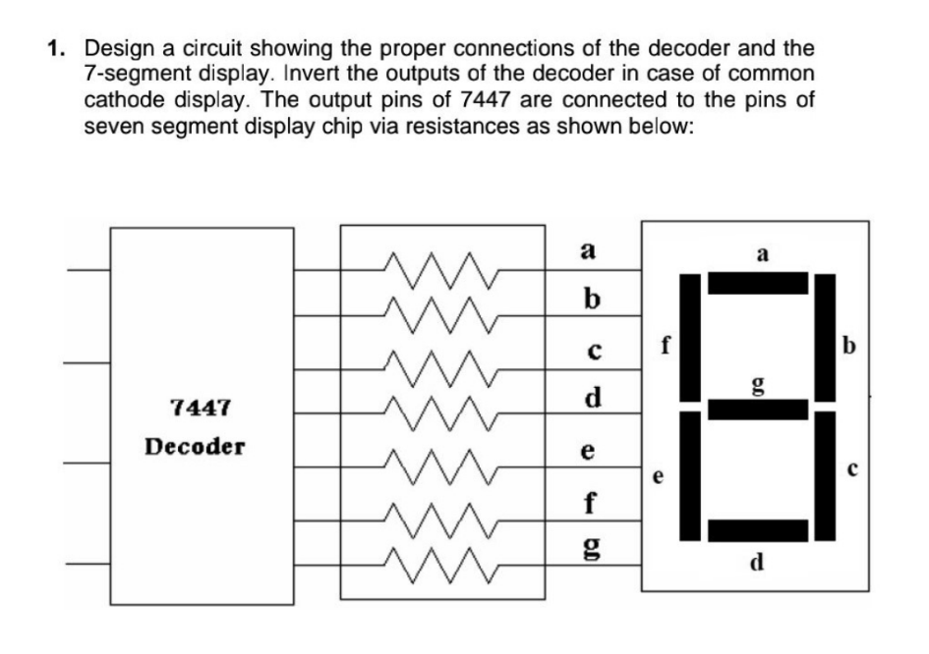

2. Implement the circuit on the trainer. Enter, BCD numbers from O to 9 and see the corresponding decimal digit on the display.

Student Exercise:

Make K-maps for each of the output of the BCD to 7-segment decoder. Find out the minimal SOP for each output. Design the decoder using minimum number of gates.

Equation for “a”: CD

00

01 11

10

1

0

1

1

0

1

1

1

X

X

X

X

1

1

X

X

## AB

1

1

00

01

11

10



F=A+C+BD+B’D’

Equation for “b”:

CD

00

01 11

10

1

0

1

1

0

1

1

1

X

X

X

X

1

1

X

X

AB

00

01

11

10

F=B’+C’D’+CD

Equation for “c”:

## CD

AB 00 01 11 10

1

1

1

0

1

1

1

1

X

X

X

X

1

1

X

X

00

01

11

10

F=B+D+C’

Equation for “d”: CD

## AB

00

01

11

10

00

01 11

10

1

0

1

1

0

1

0

1

X

X

X

X

1

1

X

X

F=A+B’C+CD’+B’D’+BC’D

Equation for “e”:

## CD

AB 00 01 11 10

|  |  |  |  |
| --- | --- | --- | --- |
| 1 | 0 | 0 | 1 |
| 0 | 0 | 0 | 1 |
| X | X | X | X |
| 1 | 0 | X | X |

00

01

11

10

F=CD’+B’D’

Equation for “f”:

## CD

AB 00 01 11 10

1

0

0

0

1

1

0

1

X

X

X

X

1

1

X

X

00

01

11

10

F=A+BD’+BC’+C’D’

Equation for “g”: CD

## AB

00

01

11

10

00

01 11

10

0

0

1

1

1

0

1

1

X

X

X

X

1

1

X

X

## **F**=A+B+CD’+B’C

Circuit Diagram:

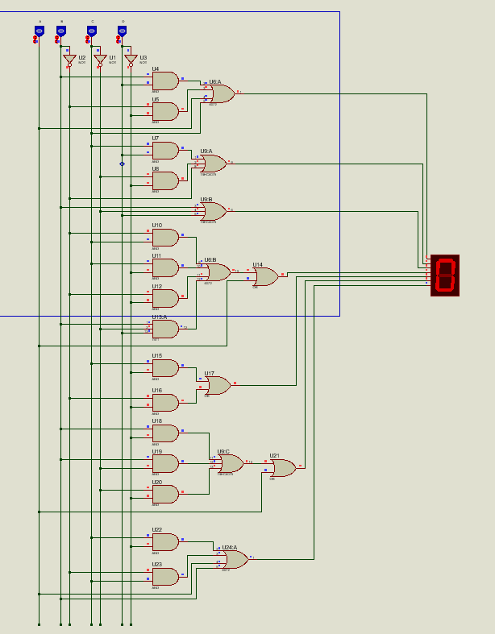

Circuit Diagram:

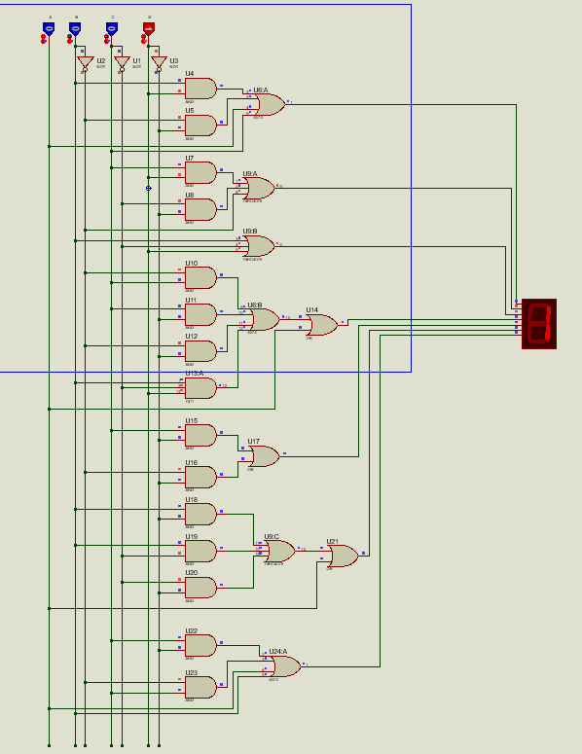

Circuit Diagram:

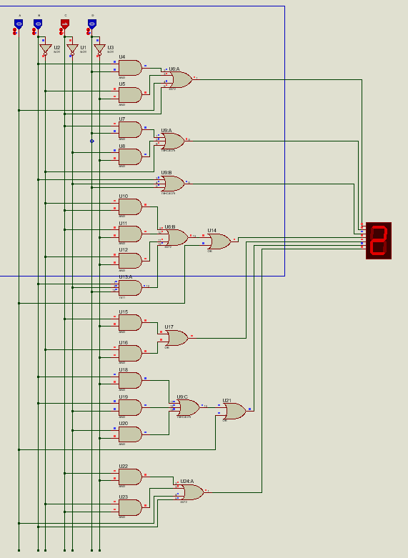

Circuit Diagram:

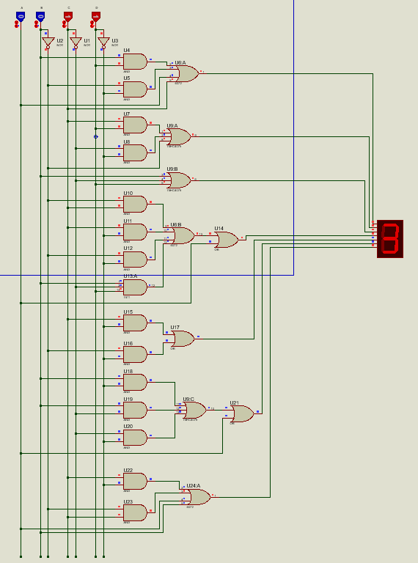

Circuit Diagram:

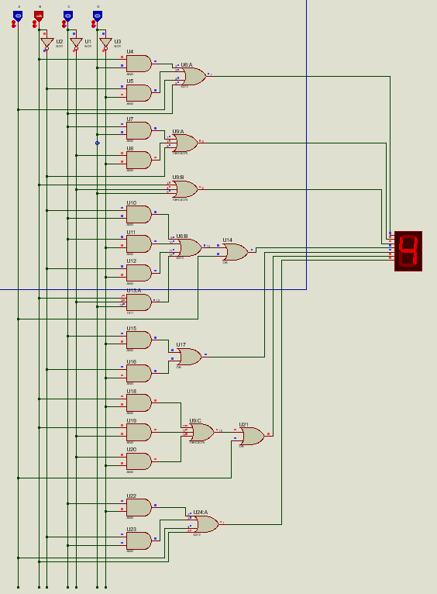

Circuit Diagram:

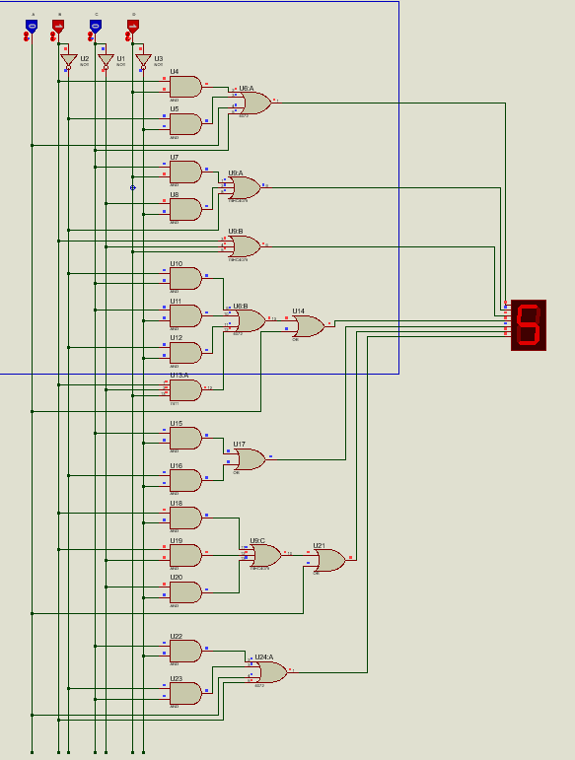

Circuit Diagram:

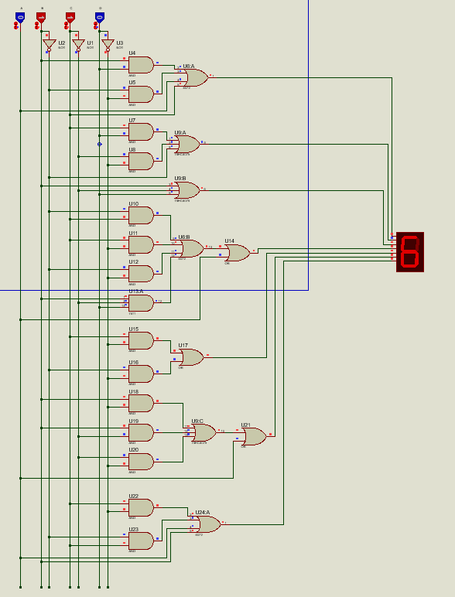

Circuit Diagram:

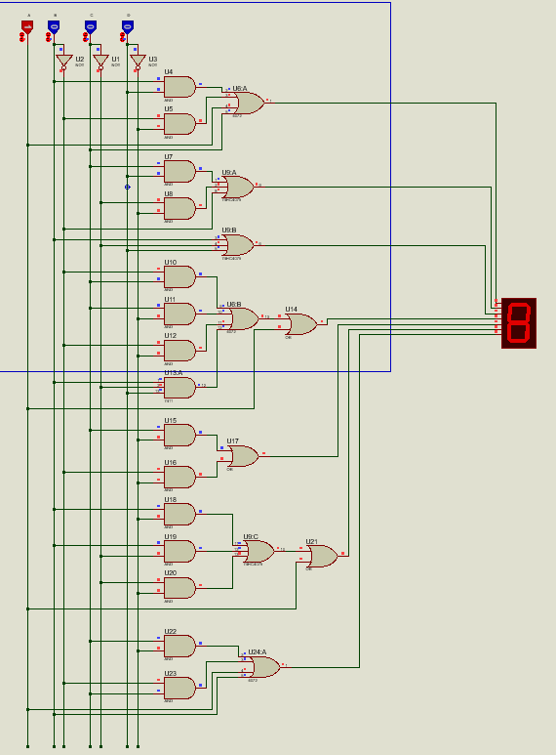

Circuit Diagram:

